|  |  |
| --- | --- |
| **Purpose:** |  |
| **Date:** |  |
| **Coordinates** | |  |  |  | | --- | --- | --- | | **A-P** | **M-L** | **D-V** | |  |  |  | |  |  | Start: | |  |  | End: | |
| **Weight:** |  |
| **Dose:** |  |
| **Volume Injected:** |  |
| **Injection type:** |  |
| **Notes/Bleeding:** |  |

# Prepare virus

Keep virus cool in cold block and on ice

## Cleaning Hamilton microliter syringe

Soak the syringe in 70% EtOH under sonication. Do not soak them for longer than 5 minutes.

If the plunger does not start to move after this, you will need to replace the syringe.

Proper cleaning will help prevent frozen plungers. Especially when the syringes are being used for life science applications, where sugary or protein based sample are required. We recommend using a like solvent to dissolves the sample. Rinse the syringe thoroughly and then remove the plunger and allow the syringe and plunger to air dry separately.

# Injection procedure

1. Set up stereotaxic frame.
2. Set up isoflurane vaporizer (2%).

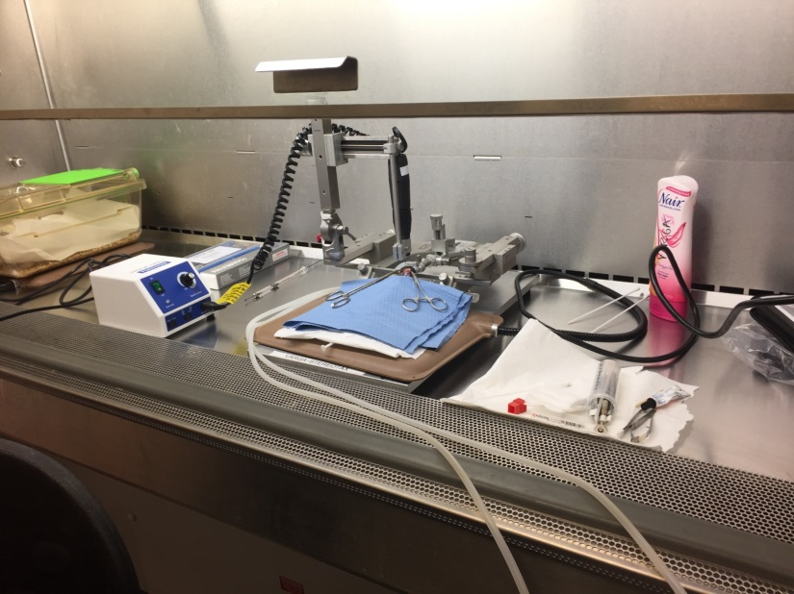

1. Anesthetize and load/prep animal.
2. Nair, inject lactated ringer, apply eye ointment
3. Midline incision (from between ears to just behind eyes), hemostat skin, H2O2 skull surface
4. Level the head:

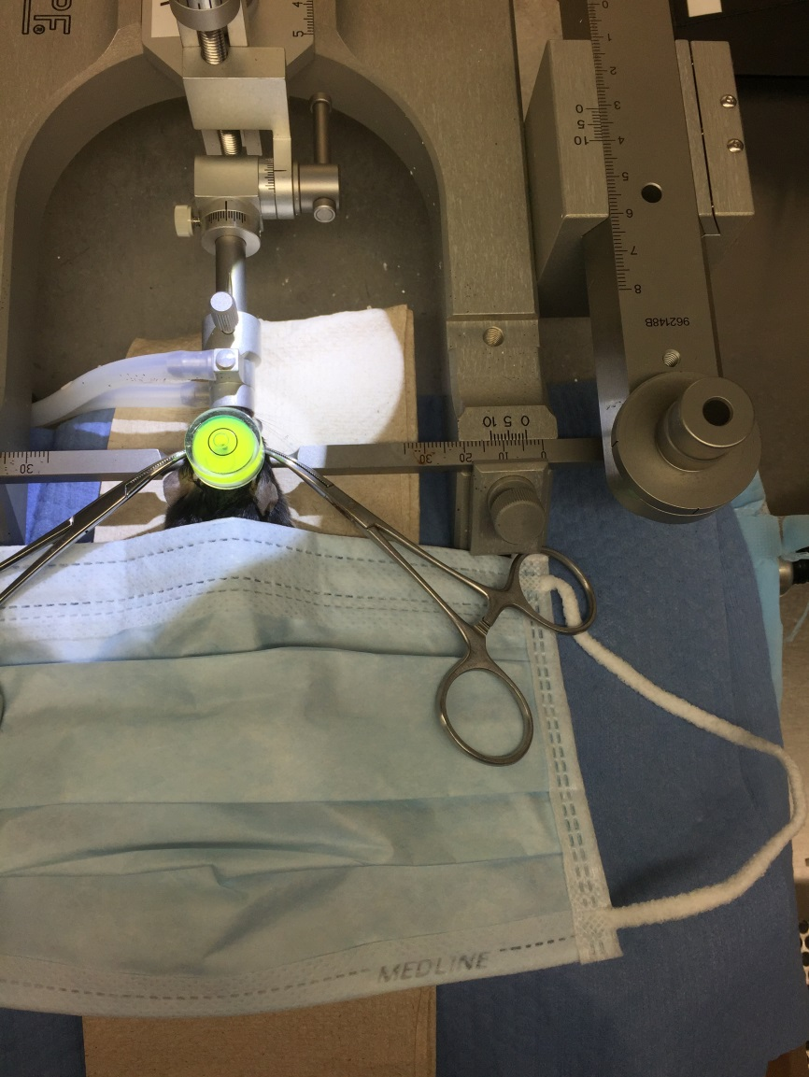

1. Set up drill (on left arm), measure Bregma/Lambda, drill holes (withdrawing once fluid emerges)
2. Lower Isoflurane to 1.5%
3. Load Syringe into Kopf adapter
4. Set up right arm.
5. Attach syringe+adapter:

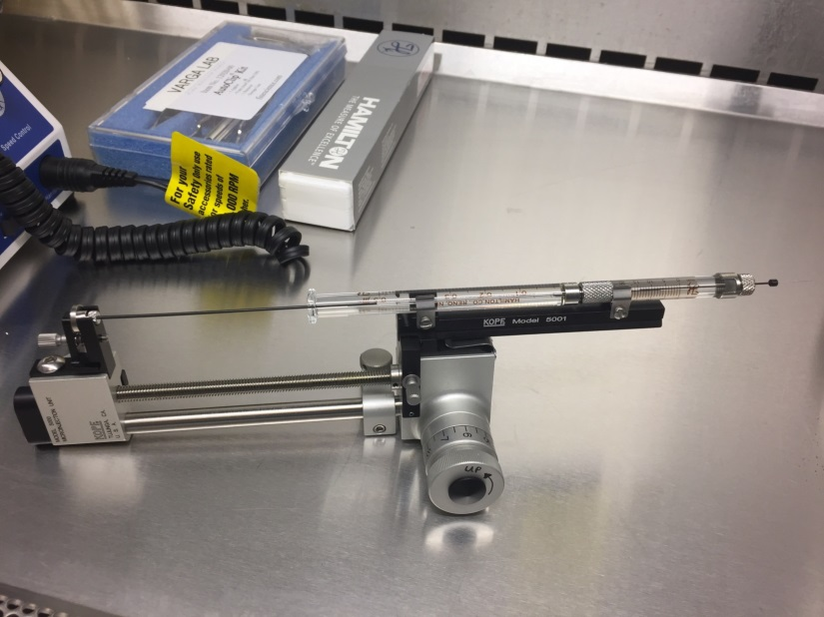

1. Backfill syringe with cargo.
2. Approach Right side bore hole. Zero the “Start Z” coordinate (D-V axis).
3. Go to “End Z -0.02”. Hold for 10 sec. Make pocket for virus.
4. Pull back to “End Z”. Inject manually (as slowly as possible).
5. Wait 10 min for virus to diffuse:

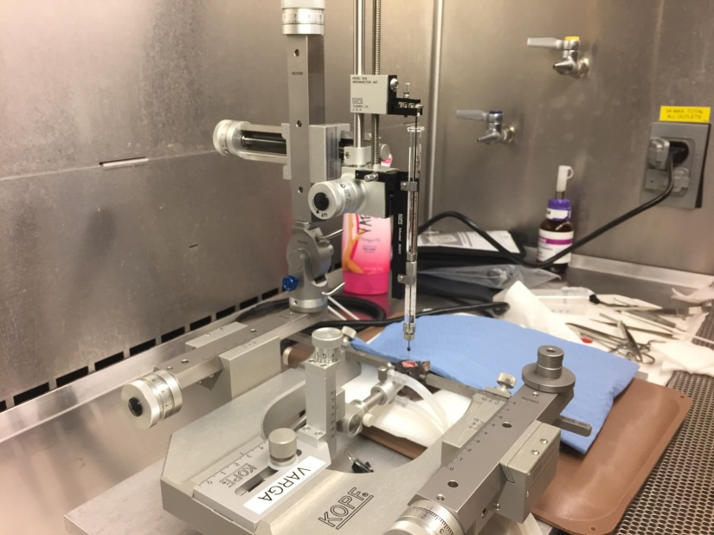

1. Pull back to “End +0.02”. Hold for 5 min.
2. Slowly, pull out of brain.
3. Reload syringe for other injection site.
4. Repeat steps for Left side.
5. Drop isoflurane to 1.0%.
6. When done, apply small drop of cyanoacrylate glue to bore holes.
7. Suture with autoclip.
8. Inject lactated ringer.
9. Allow mouse to recover in cage on heating pad; use a paper towel to prevent choking on bedding
10. Monitor breathing as mouse comes out from under anesthesia.

# Prepare Neuros Syringe

Clean out syringe

Backfill with virus (do this when syringe+adapter is on frame)

# General Surgical Considerations

**Surgery location**

Rodents are mammals belonging to the order Rodentia, characterized by large incisor modified for gnawing or nibbling e.g. rats, mice, squirrel, guinea pig. Rabbits are not rodents. Rabbits belong to the order Lagomorpha and are characterized by presence of peg teeth. The requirements for rodent surgery are different from other species. A dedicated surgical facility is not required for rodents. In general a rodent surgery should have the following components: animal preparation area; surgeon preparation area; holding and recovery area and a surgical area. If possible an area for euthanasia can be included.

Regardless of the location, when an area is being used for surgery no other activity should take place. Surgical preparation e.g. clipping of hair, scrubbing and anesthesia induction should be performed away from where the surgery is going to take place. The surfaces on which the surgery is going to take place must be non porous, sealed, durable and sanitizable. During surgery the area should be clean and free from clutter and access limited to people performing the procedure. The surface should be disinfected prior to surgery. Areas close to corridors and doors should be avoided because air currents can cause dust to contaminate surgical fields.

Examples of common hard surface disinfectants for desks, surgery tables, etc:

* Always follow manufacturers' recommendations.
* Alcohols (70% ethyl alcohol, 85% isopropyl alcohol) for 15 min in absence of organic mater or gross contamination.
* Quaternary ammonium compounds (Roccal, Quatricide) are rapidly inactivated by organic mater and may support growth of gram negative bacteria.
* Aldehydes e.g. glutaraldehyde (Cidex, Cide Wipes, Cetylcide-G) rapidly disinfects surfaces. Toxic. Follow OSHA exposure limits.
* Phenolics (Lysol, TBQ) less affected by organic materials than other disinfectants.
* Sodium hypochlorite (Clorox 10% solution) corrosive, activity reduced by organic matter
* Chlorine dioxide (Clidox, Alcide) kills vegetative organisms within 3 min, corrosive, activity reduced by organic mater, must be made fresh.
* Chlorhexidine (Novalsan, Hibiclens) rapidly bactericidal and persistent also effective against many viruses, active in the presence of blood.

A good rodent surgery board is a great asset. Basic supplies should include a sterile instrument pack, sterile supplies (drapes, gauze, gloves, rinse, tray), disinfectant or autoclave and/or glass bead sterilizer and a hot water blanket or heat lamp. The tips of delicate rodent surgical instruments should be inspected for damage using a magnifying lens before starting the procedures.

**Instrument preparation**

It is important that you start your surgery with sterile (autoclave, gas or chemical sterilize) instruments. Steam sterilization in an autoclave (121°C for 15 min or 131°C for 3 min) is extremely effective. Dry heat in a chamber or hot bead sterilizer (250°C for 15 sec) works equally well. Instruments must be cooled before contacting tissues. Ethylene oxide gas is a good sterilant when applied at ³ 30% relative humidity in a chamber placed in a fume hood. Ethylene oxide is very irritating to tissues therefore all instruments must be aerated for a long time before using on animals. Ethylene oxide is hazardous to people. Chemical sterilants can be used, however, effectiveness is dependent on adequate contact time with the instruments, proper mixing, age of the solution (clean and fresh) and removal of organic material from the instruments. Disinfectants should not be used as sterilants. All surfaces must be exposed and tubing must be filled with the solution. The sterilants have to be 'activated' in order to be effective. All chemicals must be rinsed from the instruments using sterile saline or sterile water to avoid tissue damage. Follow manufacturers instructions and avoid mixing incompatible compounds, and remember that most of these chemicals as hazardous agents.

|  |
| --- |
| Sterilization is the complete reduction of microbial life, which may be accomplished by heat, chemicals or radiation. Sterilants are essentially the same as sporocides. They kill all microorganisms including bacterial endospores. A sporocidal product kills all microorganisms including bacterial endospores. Disinfectants on the other hand kills 100% of vegetative (actively growing) bacteria (of certain species) under conditions specified by the Environmental Protective Agency, but are not efficacious against fungi, viruses, Mycobacterium tuberculosis or bacterial spores. These agents are only effective if used according the manufacturers instruction and may be inactivated by organic matter such as blood, body fluids or tissues. |

Examples of common chemical sterilants include:

* Always follow manufacturers' recommendations.
* 2% Glutaraldehyde for *[3]* 10 hours (Cidex, Abcocide). Shelf life 14-28 days after activation depending on type.
* 8% Formaldehyde plus 70% alcohol *[3]* 18 hours.
* 7% stabilized hydrogen peroxides *[3]* 8 hours (Accelerated Hydrogen Peroxide, Virox STF, Sporox). Shelf life 21 days.
* 7.35% hydrogen peroxide and 0.23% peracetic acid *[3]* 3 hours (EndoSpor plus). Shelf life 14 days.
* Chlorine dioxide 1:5 solution *[3]* 6 hours. Must be mixed daily (Clidox).
* 1.37% Sodium hypochlorite *[3]* 6 hours. Shelf life 14 days after activation (Alcide).

Since most rodent surgeries are done in batches, it is advisable to have more than one set of sterile instruments. It is also advisable to use a new sterile pack after four or five individual rodents. Instruments should be handled to minimize contamination for example placing on sterile drape or in an alcohol bath between cases. In addition, segregation of instruments according to function helps insure sterility for example instruments use on the skin should not be used within the abdominal cavity.

|  |  |
| --- | --- |
| Instruments being sterilized | In between animals, the instruments should be wiped clean of blood and tissues with sterile gauze, rinsed in sterile saline and sterilized using a glass bead sterilizer or soaked in a disinfectant following the manufacturer's recommendations. If a glass bead sterilizer is used remember to allow time for the instruments to cool before re-using them. If you are using a disinfectant for your instruments in between animals always rinse the disinfectant off with sterile saline before using the instruments on the next animal. |

Examples of common chemical disinfectants include:

* Always follow manufacturers' recommendations.
* Alcohols: 70% ethyl alcohol or 85% isopropyl alcohol for 15 min in absence of organic matter or gross contamination.
* Aldehydes (Cidex, Metricide, Cetylcide-G, Wavicide) high level disinfection *[3]* 45 min, re-use 14-30 days depending on formulation.
* Sodium hypochlorite (Clorox 10% solution) corrosive, activity reduced by organic matter
* Chlorine dioxide (Clidox, Alcide) kills vegetative organisms within 3 min, corrosive, activity reduced by organic mater, must be made fresh.
* Chlorhexidine (Novalsan, Hibiclens) rapidly bactericidal and persistent also effective against many viruses, active in the presence of blood.

|  |  |
| --- | --- |
| Surgical instruments being cleaned in water | At the end of the surgery soak the instruments in a disinfectant solution then clean the instruments using a brush and plenty of soap and water. Completely rinse the instruments with clean water and dry them thoroughly before storing. Some instruments may require special handling for cleaning. Autoclave or gas sterilize instruments in preparation for the next surgery whenever possible. |

**Surgeon preparation**

|  |  |  |
| --- | --- | --- |
| http://web.jhu.edu/sebin/j/b/03.jpg | http://web.jhu.edu/sebin/z/z/04.jpg | Prior to scrubbing hands, the surgeon should don a surgical cap, facemasks and clean laboratory coat or surgical scrubs. Scrubbing should be thorough beginning at the tip of the fingers all the way to the elbows using a surgical scrub containing a germicide e.g. chlorhexidine. These pictures illustrate how scrubbing should be performed. |

|  |  |
| --- | --- |
| How to dry hands with sterile towel | At the end of the scrub dry your hands with a sterile towel beginning at the tip of the fingers to the elbow. Rotate the towel and repeat the procedure on the other hand. When available, proceed to put on a sterile gown. This will require some assistance. |

|  |  |  |  |
| --- | --- | --- | --- |
| Open the paper covering on the gloves | Opening paper glove wrapper | Putting on sterile gloves | Putting on sterile gloves |

Open the paper covering (outer covering should have been previously opened) on the gloves as illustrated. Also make sure not to touch any non-sterile surfaces. If you accidentally touch a non-sterile surface with your gown or gloves discard them and proceed to gown and glove again. Whenever you are performing multiple surgeries, a fresh pair of sterile gloves should be used for each animal.

|  |  |  |
| --- | --- | --- |
| How to properly hold hands to maintain sterility | http://web.jhu.edu/sebin/z/i/11.jpg | Always maintain a zone of sterility in front of you.  Clasp your hands in front of you making sure the hands are above the table, above your waist and no higher than your shoulders. |

**Animal preparation**

**Pre-operative preparation**

Prior to surgery it is important that the subjects are properly identified. Obtain the weight, age, sex and strain, colony history, health status. Determine whether the animals have been acclimatized to the facility, generally 3-5 days rest after arriving from the vendor should be sufficient. In some instances this period may need to be up to two weeks.

Perform a physical examination to determine if the animal is healthy and active. If indicated or possible a simple laboratory examination such as a hematocrit, blood glucose, or urine analysis can be performed.

Regurgitation is seldom a concern for rodents. It is generally not necessary to fast rodents prior to surgery. In any case fasting should be limited 8-12 hours. Fasting minimizes individual response to dose to anesthetic drugs.

Administer fluids pre-operatively and consider preemptive analgesia. Apply ophthalmic ointment to the eyes following induction of anesthesia to prevent corneal drying.

**Skin preparation**

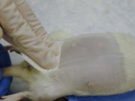Always prepare an area approximately twice the surgical area you will need. Preparation should take place at a separate location (bench or room) different than where the surgical operation will be performed. Hair should be removed from the surgical site (using clippers with #40 blade, scalpel or a depilatory cream -depilatory creams can irritate the skin, so rinse the area thoroughly after using the cream) followed by a surgical scrub alternating between disinfectant (e.g. iodophors or chlorhexidine) and alcohol. Iodophors (BetadineÒ, PrepodyneÒ, WescodyneÒ) inactivate a wide range of microbes but their activity is reduced in the presence of organic mater. Chlorhexidine (NovalsanÒ, HibiclensÒ) are rapidly bactericidal, persistent and active against many viruses. They are active even in the presence of blood.

A gauze sponge or even Q-tips can be used for scrubbing. Avoid wetting large areas of fur with alcohol because of the potential to induce hypothermia. During the scrub, the process should begin along the incision line and extend outward and never from outward (dirty) towards the center (clean).  Do not go over the incision site with the same scrub.

**Draping**

|  |  |
| --- | --- |
| Draping technique #1 | Draping technique #2 |

The decision to drape depends on the nature of the procedure being done. If it is a short procedure with minimal surgical intervention it may be okay not to drape. However, you should keep the tips of instruments within the sterile field and avoid touching un-prepared areas with your instruments. For more extensive procedures it is necessary to drape, using towels, stockinettes or plastic wraps. Drapes help to maintain a sterile field and preserve body heat.

**Heat loss**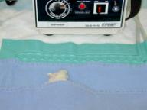

Due to their large surface to body weight ratio rodents tend to loose heat rapidly and should always be kept warm preferably with a hot water blanket, warm fluid bag or gloves filled with warm water. Heat loss also occurs from the tail, ears and feet. Loss of heat can significantly prolong the duration of anesthetic, which in turn increases the risk of complications.

**Fluid Loss**

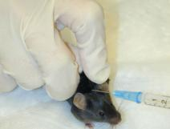Animals can experience extensive fluid loss during surgery. Fluid loss occurs primarily as a result of evaporation from body cavities and due to blood loss. Rodents because of their small size and smaller total body fluid contents are particularly  vulnerable to intra-operative fluid loss. Reduce intra-operative fluid loss by irrigating the operative field with warmed sterile saline. Administer warm, sterile isotonic fluids at 3-5% of the body weight subcutaneously prior to and at the end of surgery. Control blood loss during surgery by cauterizing or ligating potential bleeders. Monitor water and food intake and animal weight post-surgically.

**Intra-operative procedures**

Tissues should be handled gently avoiding unnecessary trauma or drying out. Only minimal dissection with appropriate instruments should be done. Blood vessels that are likely to bleed should be ligated. Avoid contamination of incisions sites.

Wounds should be closed with appropriate suture material and techniques using the right kind of needles. Non-cutting (atraumatic) taper point or round needles have no cutting edges and should be used for soft tissue like peritoneum, intestines, kidney etc. Cutting or reverse cutting needles provide a cutting edge through dense, difficult to penetrate tissues like skin.

In general absorbable sutures (e.g. cat gut, vicryl, dexon) should be used for soft tissues. Blood vessels should be ligated with slowly absorbable (e.g. vicryl, dexon, PDS, maxon) or non-absorbable sutures (e.g. nylon, silk). Non-absorbable sutures (e.g. ethilon, prolene, dermalon), surgical glue or stainless steel wound clips and staples should be used for the skin. Good surgical techniques will prevent post-surgical complications like infection, hemorrhage or even death. Proper surgical and post-surgical records should be maintained.

Non-absorbable suture materials used to close skin wounds should be removed as soon as the wound is healed (7-10 days) or within two weeks, whichever occurs first.

**Post-operative management**

Administer warmed sterile isotonic fluids and keep the animals warm using hot water blankets, hot water bottle or heat lamp (avoid burns). Animals should be checked frequently preferably every 10-15 minutes, turning from side to side until recovered. Monitor recovery from anesthesia closely and be prepared to provide respiratory support.  Monitor food and water intake after recovery from anesthesia and provide nutritional support. Administer analgesic and check for signs of discomfort or pain. The principal investigator is responsible for ensuring that post-procedural care is provided as described in the approved animal use protocol. This plan should be developed in consultation with the veterinary staff.

**Pain management**

Any procedure that causes pain in humans is assumed to cause pain in animals. Analgesics should be administered for a length of time that ensures pain and discomfort from the procedure has subsided. Most of the information on analgesia in animals (rodents) is subjective and anecdotal due to the absence of sufficient published values for serum drug concentrations corresponding to an analgesic dosage. Putting any agent in the water runs the risk of inaccurate dosing, lack of consumption due to palatability and degradation of the agent due to hydrolysis. Methods for delivery of analgesics to rodents are primarily limited to parenteral rather than oral delivery.

**Signs of pain**

The following are signs indicating that an animal may be in pain.

* Anorexia indicated by the absence of feces in cage
* Does not drink water leading to dehydration evidenced by tenting of the skin
* Hunched up, unwilling to move, favoring a limb or guarding the incision site
* Failure to groom reflected in a ruffled or dirty coat
* Excessive licking/scratching, redness and swelling at incision site, and self-mutilation
* Aggressive behavior especially when attempting to pick up the animal
* Squealing, struggling, teeth grinding, twitching, tremors, convulsions, weakness
* Panting, labored breathing, reddish-brown nasal/ocular discharge
* Cold or blue extremities (hypothermia) or hot or red extremities (hyperthermia)

**Opioids**

Oral opioids are predominantly used for chronic low intensity pain in humans but it is of questionable value versus acute, higher intensity pain in laboratory animals because of marked first pass metabolism leading to difficulty in achieving efficacious blood and tissue drug levels. They are also difficult to administer en masse. Morphine, oxycodone, meperidine and pentozocine are reportedly unpalatable and ineffective in rodents while buprenorphine in jello has been reported to be effective.

Buprenorphine is a potent partial mu-agonist, with a long duration of action (6-8 hours), but has a ceiling effect (i.e. increasing the amount of drug does not increase analgesic effect beyond a certain dose). Always use low to mid range dosage value. Buprenorhine is markedly sedative. Rats may develop pica following high doses; place rats on paper bedding until fully recovered. It may cause excessive postoperative locomotion in scid/scid mice and affect wound healing if used in combination with tribromoethanol in these mice.

Fentanyl is a potent and short acting opioid agonist, which provides analgesia during surgery. It is not effective to manage acute postoperative or severe pain unless preceded by oral or parenteral opioids. It can be initiated pre-operatively for mild pain. It is strong respiratory depressant. Transmucosal sufentanil and alfentanil produce profound analgesia, sedation and apnea in rats. Intrathecal alfentanil and sufentanil provide potent local analgesia in rodents.

Nalbuphine, a mixed opioid agonist/antagonist, is effective for 2-4 hours. It also has a ceiling effect. It reverses Fentanyl (mu receptors) while maintaining some analgesic action through kappa receptors.

Morphine and oxymorphone provide excellent 2-3 hour duration analgesia. A slow release form Duromorph available. Codeine and dihydrocodeine are of low and moderate potency respectively. Combinations with paracetamol available are available. It suppresses coughing. Meperidine (pethidine, dolantin, eudolat, isonipecaine, demerol) is a spasmolytic for smooth muscle. Oral or injectable forms are available.  Meperidine causes profound histamine release. Do not give intravenously.

Butorphanol tartrate (stadol, torbugesic, torbutrol) is a mixed agonist/antagonist. This is a marked mu antagonist that can reverse fentanyl while maintaining some analgesic action through kappa receptors. It provides moderate analgesia for 2-4 hours. Always determine whether you are using human or veterinary preparation. Pentazocine has less sedative effects than morphine. Oral or injectable formulations are available.

Naloxone is an opioid antagonist. It reverses effects of agonists and agonists/antagonists. It has a short duration of action and no analgesic properties.

**Non-steroidal analgesics (NSAIDS)**

Ketoprofen is the least likely to produce side effects in multiple species. It is available as tablets and injectable forms (Actron, Ketofen, Orudis). Related drugs include Ibuprofen, Carprofen, Fenoprofen and Naproxen. All have analgesic, anti-pyretic and anti-inflammatory activity. Ibuprofen (Advil, Nuprin, Motrim) is efficacious in multiple species for pain of inflammatory origin. There are no studies to evaluate its efficacy or toxicity in rodents. Oral forms are available. Caprofen (Rimadyl) is a good analgesic for rats and is available in oral and injectable forms. It has anti-inflammatory, antipyretic and analgesic activities and is indicated in osteoarthritis.

Aspirin relieves only mild to moderate and not deep visceral pain. Injectable forms are available. It may cause gastrointestinal hemorrhage.

Acetaminophen is unpalatable in rats and does not show detectable analgesic potency. Effects are similar to aspirin but it is not anti-inflammatory. There is less gastrointestinal irritation; over dosage causes liver toxicity. It is available in tablets, capsules, suppositories, chewable tablets, wafers, elixirs and solutions. It is available in combination with other drugs.

Indomethacin is antipyretic, analgesic and anti-inflammatory but toxicity limits its use. It is available as tablets. Related compounds are Sulindac, Diclofenac, Tolmetin and Ketorolac.  Ketorolac is similar to aspirin in action but does not irreversibly interfere with platelet function but its adverse gastro-intestinal effects may be higher. Oral and injectable forms are available.

Flunixin meglumine has minimal analgesic efficacy for rodents. Gastrointestinal and renal toxicity risks increase with concurrent steroid use. Causes significant irritation when given subcutaneously. Administer every 12 hours.

**Anesthesia**

Anesthesia is the loss of sensitivity to the whole or part of the body. Proper anesthesia should provide adequate analgesia. Under general anesthesia there is complete muscle relaxation, unconsciousness and amnesia.

Many factors affect the amount of anesthetic required. As a general rule, the smaller the animal (species) the more rapidly it is able to metabolize and excrete the agent. Therefore, a smaller species may require somewhat higher dose for induction and maintenance than a larger species. Very young and very old or sick animals may metabolize anesthetics at a slower rate and usually need a lower dose of the agent. Obese animals have a low metabolic rate and may metabolize anesthetic agents more slowly than lean animals. However, some anesthetic agents accumulate in fat increasing the total amount needed and prolonging recovery from anesthesia. Eating increases the metabolic rate, hence amount of anesthetic required. Eating also increases the risk of vomiting and attendant complications. High ambient temperature promotes metabolism whereas a low ambient temperature reduces metabolic rate. Other factors that affect anesthetic requirements include species, strain, sex, biological rhythms, pregnancy, lactation and concomitant use of other drugs.

Rodents present unique challenges due to need for "herd" (multiple animals simultaneously) anesthesia and analgesia, poor accessibility of peripheral vessels, the tendency for investigators to administer drugs as premixes, drug bias by certain disciplines e.g. avertin for transgenic work, multiple species and strain differences and lack of information on hamsters, gerbils, guinea pigs. These problems are compounded by infrequent and/or inadequate monitoring of parameters, difficulty in judging anesthetic and analgesic depth or muscle tone, choice of drugs based on expense, available equipment and wide variation in anesthetist's skills.

**Stages of anesthesia**

During induction of general anesthesia, animals pass through various stages indicative of the level of anesthesia.

* **Stage 1** — excitatory, disorientation, vocalization, urination, defecation.
* **Stage 2** — loss of consciousness with or without struggling and whining, many reflexes are intact but righting reflex is lost, rapid irregular breathing and rigidity.
* **Stage 3** — surgical stage of anesthesia, with loss of reflexes, muscle relaxation, deep and rhythmic breathing, planes 1-4 (light to deep).
* **Stage 4** — medullary paralysis with respiratory arrest, hypotension and imminent death. Cardio-pulmonary resuscitation and drugs to reverse anesthesia must be given or animal will die.

**Signs of inadequate anesthesia**

Adequate general anesthesia is accompanied by loss of muscle tone reflected in loss of purposeful movements, however, hamsters and gerbils may retain "swimming" or purposeless movements even in deep surgical anesthesia. There is loss of reflexes for example corneal, pinnae and pedal. There should be no response to aversive stimuli e.g. tail pinch, pinching abdominal skin with forceps and a lack of vocalization. Twitching of whiskers is lost with progression from light to medium anesthesia. There are changes in the depth and frequency of respiration and cardiovascular parameters.

**Monitoring the depth of anesthesia**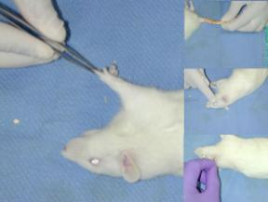

* Assess movement, stimulus perception and reflexes - [cornea, toe, tail or ear]
* Observe chest wall movement
* Pulse, heart rate, direct or indirect blood pressure (cuff or Doppler)
* Mucus membrane color at muzzle, feet, ears, tongue
* Temperature
* Ancillary equipment e.g. pulse oximetry, end tidal carbon dioxide (capnometry).

**Methods of anesthesia**

Most regimens for anesthesia and analgesia in rodents are based on clinical experience and historical empirical use. There may be significant strain differences in response to anesthetic agents that has to be taken into account. Surgeries in mice tend to be short due to small size, greater anesthetic risks and surgical skills required.

**Hypothermia**

Hypothermia is an appropriate form of anesthesia and analgesia for neonatal rodents, usually up to 5 days old. Hypothermia is used clinically in humans for neurosurgery and open-heart surgery. Rats subjected to cold-water swim exhibit an analgesic potency similar to morphine 10 mg/kg SC up to 30 min after removal from hypothermia.

Hypothermia is induced by placing newborn pups inside a glove finger on crushed ice or in paper-lined tubes packed in crushed ice until the pup no longer responds to a toe pinch. Pups should not come into direct contact with cold surfaces to avoid frost-bite. Recovery can be rapid, however, avoid aggressive rewarming (heat pads or heat lamps) as it can result in tissue damage. Pups can also be placed in an incubator at 33°C for 20-30 min.

Newborn rodents are especially good subjects because they are poikilothermic. Their small size and body mass makes rapid core cooling feasible through surface cooling. They are also more resistant to arrest of blood supply to the brain and tolerate extended periods of 1°C body temperature without known negative effects. Risks include ventricular fibrillation, tissue hypoxia and metabolic acidosis on warming.

**Inhalant anesthetics**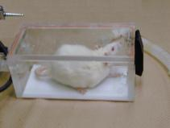

Inhalant anesthetics provide increased operator control of depth and duration of anesthesia increasing survivability. Always use of agents requiring minimal metabolism, biotransformation or excretion to reduce variability in research results. Waste anesthetic gases can adversely affect personnel therefore a scavenging system should always be used. The guinea pig cecum may act as a reservoir for anesthetic gases.

Inhalant anesthetic agents often require specialized equipment e.g. precission vaporizer, laryngoscopes, endotracheal tubes, masks, scavengers, anesthetic chambers and oxygen.

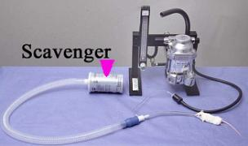In a non-rebreathing system exhaled anesthetic mixture is released to atmosphere while in a rebreathing system carbon dioxide is removed by soda lime and remaining mixture plus oxygen is recirculated, decreasing anesthetic and oxygen use. Rebreathing systems are not practical in rodents due to dead space. Precision vaporizers should be serviced and calibrated every year.

|  |  |
| --- | --- |
| open drop method | The open drop method does not require specialized equipment, however, the trade off is no control over anesthetic depth and greater risks to personnel. It is critical to avoid direct contact of the agent with the animal (and person's) skin when using the open drop method. |

**Halothane (Fluothane)**

Halothane is a potent non-flammable and non-irritating anesthetic. Halothane is very volatile allowing for rapid induction and recovery. Use of halothane requires precision vaporizer specific for halothane. Halothane is not very soluble in tissue and up to 20% is metabolized by liver. Halothane is hepatotoxic. The guinea pig is a model for acute halothane-induced hepatotoxicity. Despite this drawback, halothane is still a very useful anesthetic in guinea pigs. Halothane also interferes with interferon stimulated Natural Killer cell activity in mice. It is neuroprotective in the rat brain ischemia model.

**Isoflurane (Forane)**

Isoflurane is very volatile allowing for rapid induction and recovery. A precision vaporizer specific for isoflurane is required to safely use isoflurane. Less than 0.25% of inhaled isoflurane is metabolized by the liver. It produces minimal cardiovascular and respiratory depression. There are strain differences in the response to isoflurane: hypertensive rats (SHR, WKY) are more sensitive than normotensive (SD) rats. There is a transient postoperative immunosuppression in mice and humans following use of isoflurane. Guinea pigs more sensitive than other rodents to isoflurane.

In absence of a vaporizer the following dilutions should be used for halothane or isoflurane to avoid over-anesthesia and killing animals.

0.05 ml per liter volume of container equals 1%

0.10 ml per liter volume of container equals 2%

0.15 ml per liter volume of container equals 3%

0.20 ml per liter volume of container equals 4%

**Ether**

Ether is very irritating to respiratory passages and is explosive. Always give atropine prior to exposure to ether. The use of ether in any facility at Johns Hopkins is regulated by the Biosafety Office (5-5918). Ether can be used by open drop in an approved explosion proof  fume hood. Induction takes 5-10 min. There are strain differences in sensitivity to ether: C3H>BALB/c>DBA/2>ICR>C57Bl6. Ether does not change hematologic values (e.g. packed cell volume, erythrocyte or leukocyte counts or differential) but it increases liver microsomal enzymes, depresses hypothalamic activity and alters blood glucose. It can cause liver necrosis, excessive salivation and respiratory irritation. Ether is a satisfactory anesthetic in gerbils but expect emergencies and fatality. It is unsafe in guinea pigs.

The effective concentration of ether to produce anesthesia is 1.9%. This concentration can be produced with 0.08 ml per liter of volume of container.

* Ether and any device used to contain it should be stored in a vented NFPA flammable material cabinet.
* Ether should be ordered in the smallest volume needed
* The container should be dated when received and again when opened
* Ether should be used only in a properly functioning chemical fume hood or Biosafety cabinet. At the recommended concentration ether can be safely used in a Biosafety cabinet.
* Opened ether should be sent for disposal six months after opening.

**Nitrous oxide**

Nitrous oxide provides incomplete anesthesia and must be used in conjunction with another agent. There are human health hazards associated with the use of this agent. Nitrous oxide has been used for creation of stroke models in rats and gerbils.

**Carbon dioxide**

Carbon dioxide sedation can be used for blood collection. Carbon dioxide is readily available, inexpensive, provides rapid recovery and is safe for personnel. There is a long induction time with frequent severe and possibly fatal adverse effects following moderate stress. It is not esthetically pleasant.

**Injectable anesthetics**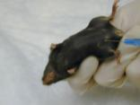

The cecum of guinea pigs may give false total body weight to calculate the amount of injectable anesthetics.

**When using injectable anesthetic rodents it is important to dilute the drug to facilitate administration of the correct dose since small volumes are used.**

The drugs may be administered intraperitoneally, intravenously or intramuscularly.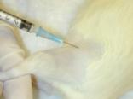 Irritant drugs should be given in small doses at multiple sites. Drugs can be administered as a bolus, intermittently or continuously. The method of administration will influence rate of absorption into the systemic circulation.

It is often safer, more effective and more convenient to supplement anesthesia with an inhalant anesthetic agent rather than re-dosing with the injectable agent.

**Barbiturates**

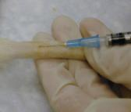Their action is influenced by strain, weight, age, nutritional status, sex, type of bedding, presence of other pharmacologic agents, and circadian rhythms.

Recently there have been problems with availability of barbiturates.

Pentobarbital (Nembutal) has a rapid onset, is non-irritating, easily administered intraperitoneally but has poor analgesic properties. The dosages necessary to produce surgical plane of anesthesia are accompanied by poor analgesia, progressive decline in blood pressure and heart rate, respiratory depression, acidosis, hypercarbia and hypoxia. Anesthesia usually lasts 30-60 min. Food deprivation enhances anesthesia, decreases latency of onset and lengthens duration of anesthesia. Rats eating within 1 hour of injection have difficulty reaching surgical plane of anesthesia. There are significant strain differences in response to pentobarbital: DBA>C57Bl6>CBA>BALB/c>NZW. Males are more sensitive than females. Within strain differences in response are due to age, sex, dose, litter size, fasting, temperature and bedding.

Thiopental (Pentothal) produces dose-dependent hypothermia, hypercarbia, acidosis, hypoxia and hypoventilation. Anesthesia is very variable usually lasting 10-20 min. Atropine should be administered when using this drug in guinea pigs and hamsters to reduce salivary and bronchial secretions. Methohexital (Brevital) has a short duration of action and quick recovery. A 40 mg/kg dose in rats 15-20 min of profound restraint but insufficient analgesia.

**Dissociative agents**

Dissociative agents disrupt input into brain so stimulation is not perceived. The animal does not appear asleep and eyes are open. Muscle tone increased with ocular, pharyngeal and laryngeal reflexes present. These agents provide very little if any analgesia. They are very acidic and sting on intramuscular injection so give it deeply or intravenously. They increase salivary secretions.

Ketamine (Ketaset) is used for restraint and minor procedures in multiple species; and is relatively safe. It produces sedation, respiratory depression, prolonged recovery, poor analgesia and poor muscle relaxation and often increased muscle tone. Ketamine alone does not produce a state of surgical anesthesia. Give tranquilizers (acepromazine) or sedative (xylazine) for muscle relaxation and anticholinergics (atropine, glycopyrrolate) to decrease salivation.

Ketamine and xylazine (a2-agonist) combination is safe and reliable for procedures of short to moderate duration but may cause hypotension, respiratory depression and hypothermia. The combination can be premixed and pre-diluted as a cocktail. It can be reversed using yohimbine, tolazoline or atipamazole (a2-antagonist). Lower doses in mice produce hyperacusia. This combination provides inconsistent and unreliable anesthetic depth in guinea pigs. Supplementation with local lidocaine infiltration provides a safe reliable anesthesia in pregnant hamsters. Ketamine and xylazine mixture produces sedation and immobility but rarely produces surgical anesthesia in gerbils with frequent 'swimming' or 'arthetoid' movements.

Ketamine and medetomidine (a2-agonist) provides rapid restraint in mice for minor procedures. Females more sensitive than males. Atipamazole is used to reverse medetomidine.

Ketamine and acetylpromazine combination may not attain surgical plane of anesthesia.

Tiletamine and zolazepam (Telazol) contains dissociative (tiletamine) and benzodiazepine tranquilizer zolazepam; may not produce adequate anesthesia in mice, guinea pigs and hamsters. It is nephrotoxic. The duration of effect is dose-dependent usually 30-60 min. Corneal, pedal, and swallowing reflexes may remain intact in rats. Telazol produces sedation but poor analgesia in guinea pigs. The long duration of effect is good for restraint. It produces immobility, poor analgesia and minor respiratory distress in hamsters. Telazol can be combined with xylazine to provide relaxation, analgesia and reduce nephrotoxicity.

**Neuroleptanalgesics**

Neuroleptanalgesics consist of a combination of an opioid agonist or mixed agonist/antagonist with a tranquilizer. Their use can result in respiratory depression, poor muscle relaxation, hyoptension and bradycardia. Naloxone or nalbuphine (mu-antagonist) can be used to reverse the effects of neuroleptanalgesics. Addition of a benzodiazepine e.g. midazolam or diazepam reduces dose of neurolepanalgesic by 50-70% and produces good skeletal muscle relaxation.

Fentanyl and Fluanisone (Hyponorm) provides sedation to short duration anesthesia, variable analgesia and some muscle rigidity in rats. Addition of midazolam to hyponorm creates a reliable and longer lasting anesthetic with good muscle relaxation and analgesia.  Premix dilution stable for 2 months.

Hyponorm plus diazepam provides excellent anesthesia and analgesia but recovery can take up to 12 hours. Hyponorm should be diluted 1:10 prior to administration in hamsters, gerbils and mice. Given intraperitoneally, hyponorm causes twitching, paddling, and extensive hyperacusia in mice.

**Tribromoethanol (Avertin)**

Popular for use in procedures to create transgenics; short duration procedures. The solution must be carefully prepared and stored to avoid tissue reactions [protect from light, store at 4ºC]. Discard if the stock solution changes color. When exposed to light or improperly stored, it decomposes to dibromoacetaldehyde and hydrobromic acid, which are potent gastrointestinal irritants, leading to fibrinous peritonitis, ileus, and fatalities. Thus, there is always a risk of chemical peritonitis associated with its use. A high mortality is experienced after repeat use. In mice 250 mg/kg intraperitoneally, produces rapid induction and recovery, good muscle relaxation. Cardiovascular and respiratory depression occurs at high doses.

**Local anesthetic agents**

Local anesthetic agents provide anesthesia by blocking the conduction of nerve impulses, both sensory and motor. The effect on motor neurons produces muscles relaxation. In large doses they are toxic and can produce neurotoxicity and cardiovascular collapse following accidental intravenous injection. Along the spinal cord it can block muscles controlling respiration resulting in respiratory arrest, and it can affect muscles responsible for vascular tone resulting in hypotension.

EMLA cream takes 30-45 min to be effective. It is useful for venipuncture. Lidocaine and bupivacaine with or without a vasoconstrictor (e.g. epinephrine) are useful for nerve blocks e.g. after thoracotomy and orthopedic procedure, and in ophthalmic procedures.

**Vendors commonly used by Comparative Medicine**

Samuel Perkins Co. Inc., 497 Beale Street, Quincy, MA. sperkins@gis.net  
Barber Vet Supply, 1-800-552-5698  
AJ Buck & Sons, 1-800-638-8672  
Penn Vet Supply, 1-800-548-4490  
Hospital Pharmacy, 410-955-6591  
Clinical Engineering Services, 114 Brady Building 410-955-5639

# References

1. <http://web.jhu.edu/animalcare/procedures/survival-rodents.html>
2. Anesthesia and analgesia in laboratory animals. Kohn DF, Wixson SK, White WJ, Benson GJ (eds.) Academic Press. San Diego. 1997
3. Laboratory animal anesthesia. Flecknell PF. Academic Press. London. 1996.
4. Formulary for laboratory animals. Hawk CT, Leary SL. Iowa State University Press, Ames. 1999.
5. Lumb & Jones' Veterinary Anesthesia. Thurmon JC, Tranquilli WJ, Benson GJ (eds.). Williams & Wilkins, Baltimore. 1996.
6. Experimental and surgical techniques in the rat. 2nd edition. Waynworth HB, Flecknell PA. Academic Press, London. 1994.
7. Direct Intraventricular Delivery of Drugs to the Rodent Central Nervous System
8. Optogenetic interrogation of neural circuits- technology for probing mammalian brain structures
9. Stereotaxic Microinjection of Viral Vectors Expressing Cre Recombinase to Study the Role of Target Genes in Cocaine Conditioned Place Preference